Title of Paper

Satoru Hashimoto

Course Number (ORG500) – Name of Course (Foundations of Effective Management)

Colorado State University – Global Campus

Instructor’s Name

August 6, 2018

Star Schema for Data Warehouse

When making a logical star schema for the jigsaw database, I used the pgadmin graphical interface to view all rows of the existing tables. I would have liked to view all of the tables simultaneously by using the SQL command SELECT \*, however, I was unable to do this as I couldn’t find the command line that would query the jigsaw database as a whole. I eventually settled for viewing the tables individually which ended up working fine. Denormalization would have been simpler if I could see all of the tables together on the same view in order to add redundant columns to the schema’s dimension tables. For the fact table, I decided it may be useful to reference a surrogate key in lieu of a large combination of foreign keys. I’m not sure how this would or wouldn’t cause problems in a practical scenario. Compared to the frustrations I experienced last week, I experienced relatively few problems this week, to the extent that I feel like maybe I’m missing something important. I used the text (Mannino, 2019) as a reference to guide me through the star schema’s requirements as well as looking at examples on google images as a research methodology. Overall I think I did well on this assignment but feel like I may be missing something major.

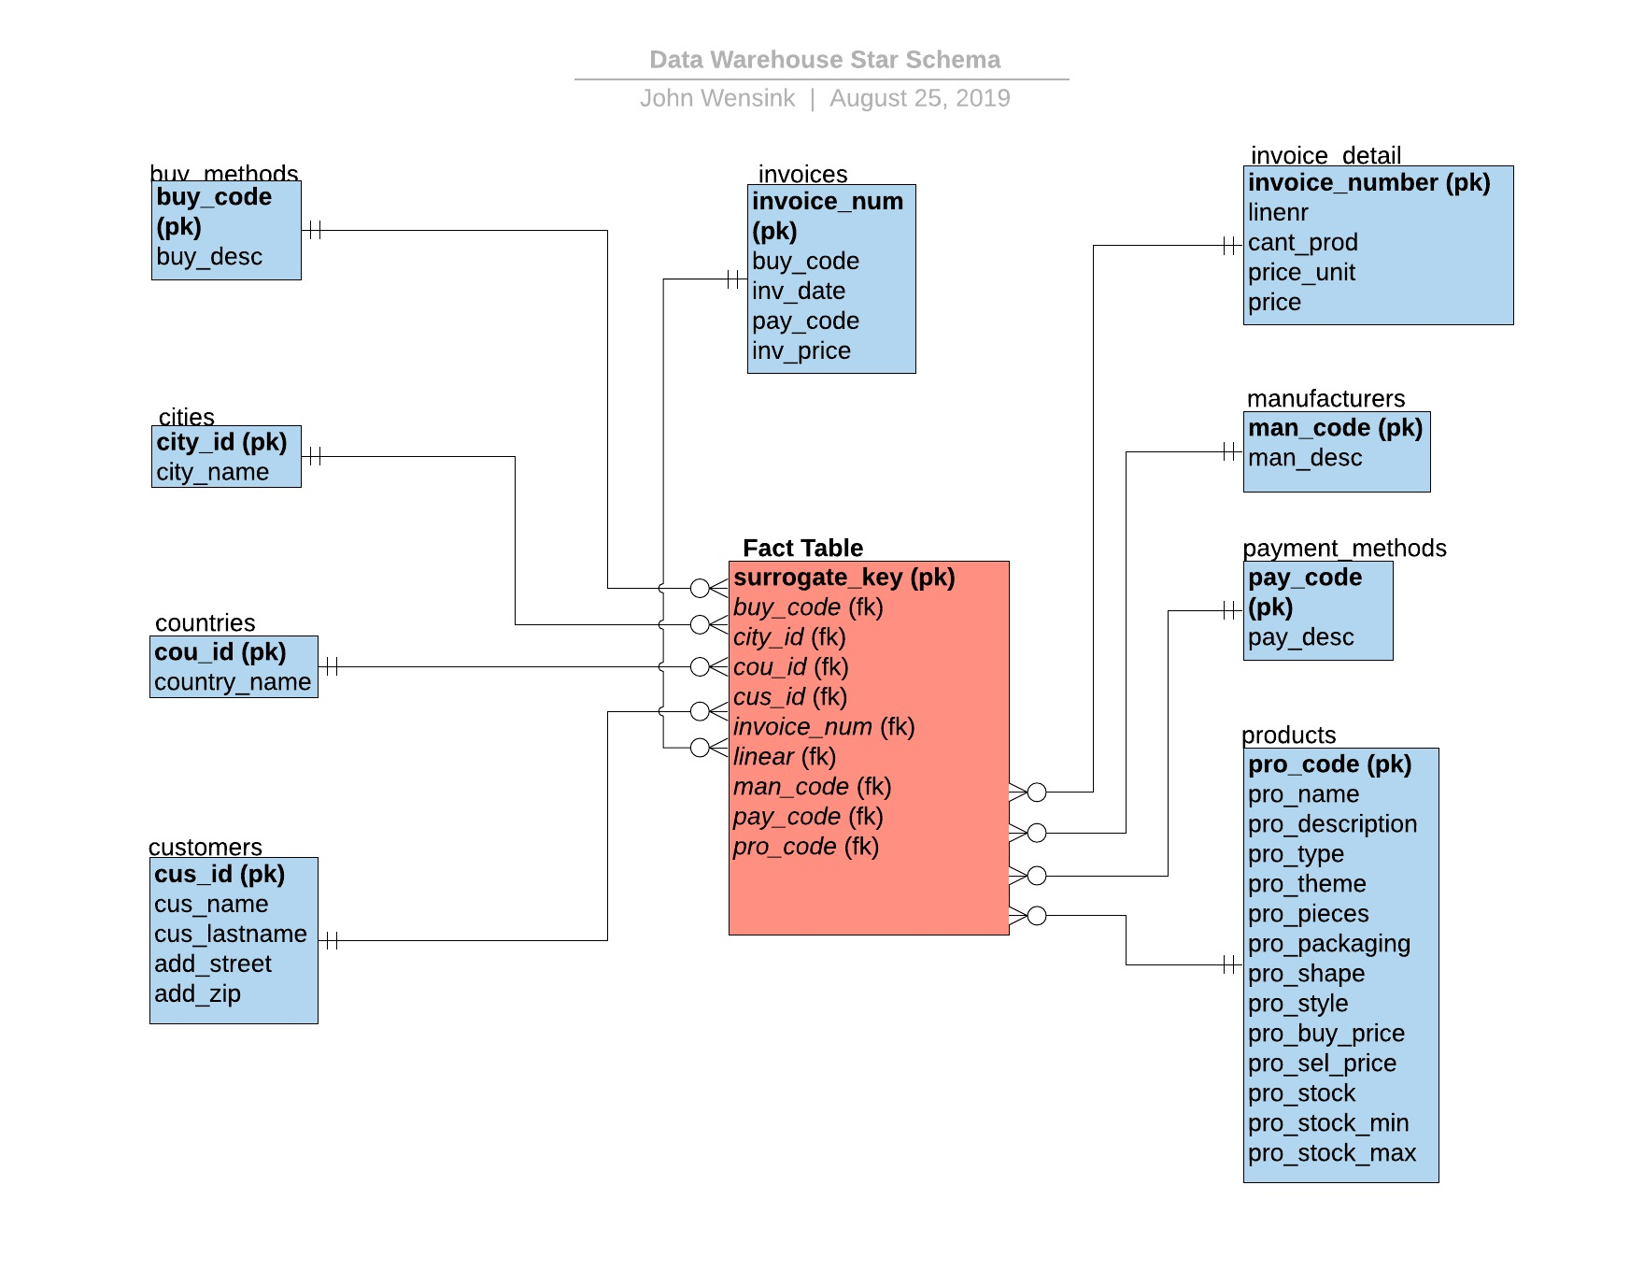

References

Mannino, M. (2019). Database design, application development, and administration (7th ed.). Retrieved August 25, 2019, from

<https://platform.virdocs.com/r/s/0/doc/592088/sp/46211890/mi/190879798?cfi=%2F4%2F8>